Table of Contents
Overview 2
The Reality Check: Why Enterprise AI Projects Struggle 3
The Data Fragmentation Challenge 3
Security Concerns as the Primary Barrier 3
The Skills and Implementation Gap 3
Our Five-Stage Methodology: Lessons Learned in Practice 4
Stage 1: Strategic Assessment and Risk Evaluation 4
Business Case Development and Value Quantification 4
AI Maturity Assessment 5
Security and Compliance Framework Development 5
Stage 2: Security-First Architecture Design 5
Zero-Trust Network Implementation 5
Data Classification and Tiered Protection 5
Privacy-Enhancing Technology Integration 6
Stage 3: Data Governance and Preprocessing 6
Data Quality Enhancement 6
Sensitive Information De-identification 6
Secure Prompt Engineering 6
Stage 4: Secure Deployment and Integration 7
Sandboxed Testing Environments 7
Progressive Production Deployment 7
Secure System Integration 7
Stage 5: Continuous Monitoring and Optimization 7
AI Behavior Anomaly Detection 7
Threat Response and Incident Management 8
Compliance Monitoring and Continuous Improvement 8
Our Journey and Learnings 8
Building Deep Industry Understanding 8
Developing Full-Stack Security Capabilities 8
Refining Project Management and Risk Mitigation 8
Looking Forward: The Path to AI-Driven Enterprise Success 9

Navigating AI Transformation: ZOKFORCE's Five-Stage LLM Implementation Methodology

Overview
Over the past few years, as enterprises worldwide have embarked on their AI transformation journeys, we at ZOKFORCE have had the privilege of witnessing—and learning from—both the remarkable successes and challenging setbacks in this rapidly evolving landscape. As a growing AI consulting firm, our experiences working alongside forward-thinking organizations have taught us valuable lessons about what it truly takes to implement Large Language Models (LLMs) successfully in enterprise environments.
The statistics are sobering: MIT research reveals that 95% of enterprise generative AI pilots fail to meet their objectives, while over 60% of corporate AI projects fall short of achieving expected returns on investment. Through our journey of supporting various organizations in their AI adoption efforts, we've observed that success rarely stems from having the most advanced technology alone—it requires a systematic, security-first approach that addresses the fundamental challenges enterprises face.^{[1][2]}
Drawing from our experiences, successes, and admittedly, our failures, we've developed what we call the "Five-Stage Enterprise LLM Implementation Methodology." This framework represents our collective learnings and represents our commitment to helping organizations navigate the complex landscape of AI transformation while maintaining the security and compliance standards their stakeholders demand.
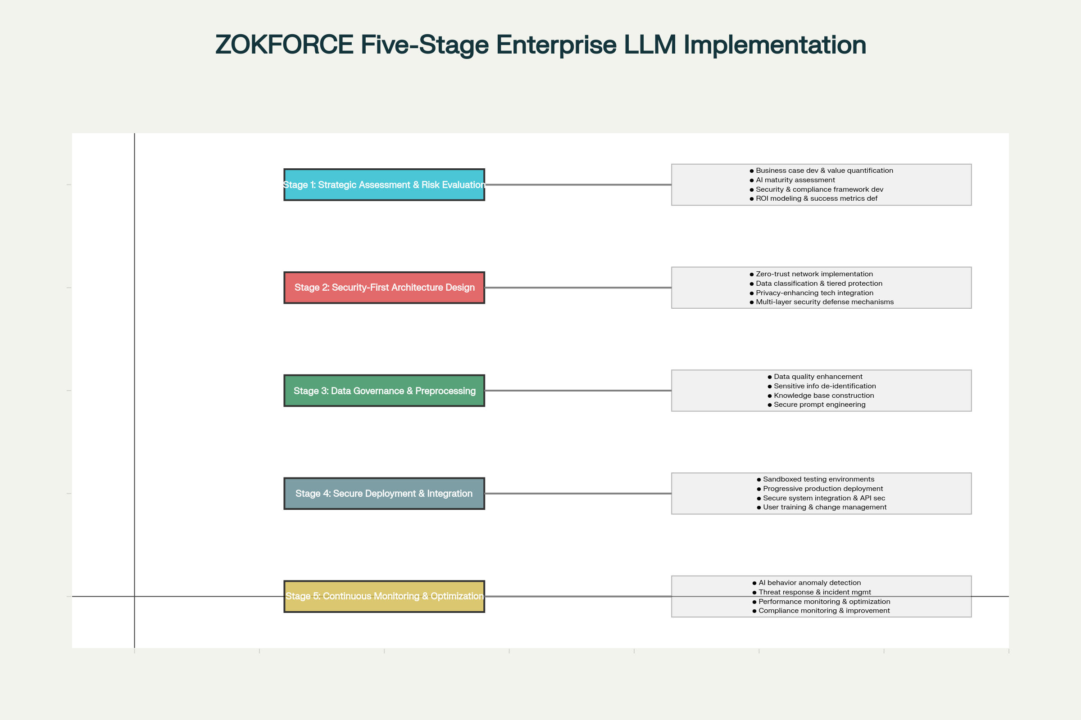
ZOKFORCE's Five-Stage Enterprise LLM Implementation Methodology

The Reality Check: Why Enterprise AI Projects Struggle

The Data Fragmentation Challenge
Throughout our engagements, we've consistently encountered what industry experts call the "data island problem." Research indicates that 99% of enterprise core data remains unused by AI systems, scattered across departmental silos in legacy ERP systems, inconsistent CRM databases, and various operational platforms. This fragmentation doesn't just limit AI model training—it fundamentally undermines the value proposition of AI initiatives.^{[3][4]}

Security Concerns as the Primary Barrier
Our client conversations repeatedly surface a critical concern: 70% of enterprises view rapidly advancing AI as a significant security risk. The fear of data leakage through prompt injection attacks, model memory contamination, or unauthorized third-party access has become the single largest psychological barrier to AI adoption in mission-critical business scenarios.^{[5][6][7]}

The Skills and Implementation Gap
We've learned that 40% of organizations lack sufficient AI expertise to achieve their stated objectives. Even when companies successfully recruit top talent, implementing AI in complex enterprise environments requires orchestrating expertise across data engineering, cloud infrastructure, cybersecurity, and domain-specific knowledge—a challenge that extends far beyond individual capabilities.^{[8]}
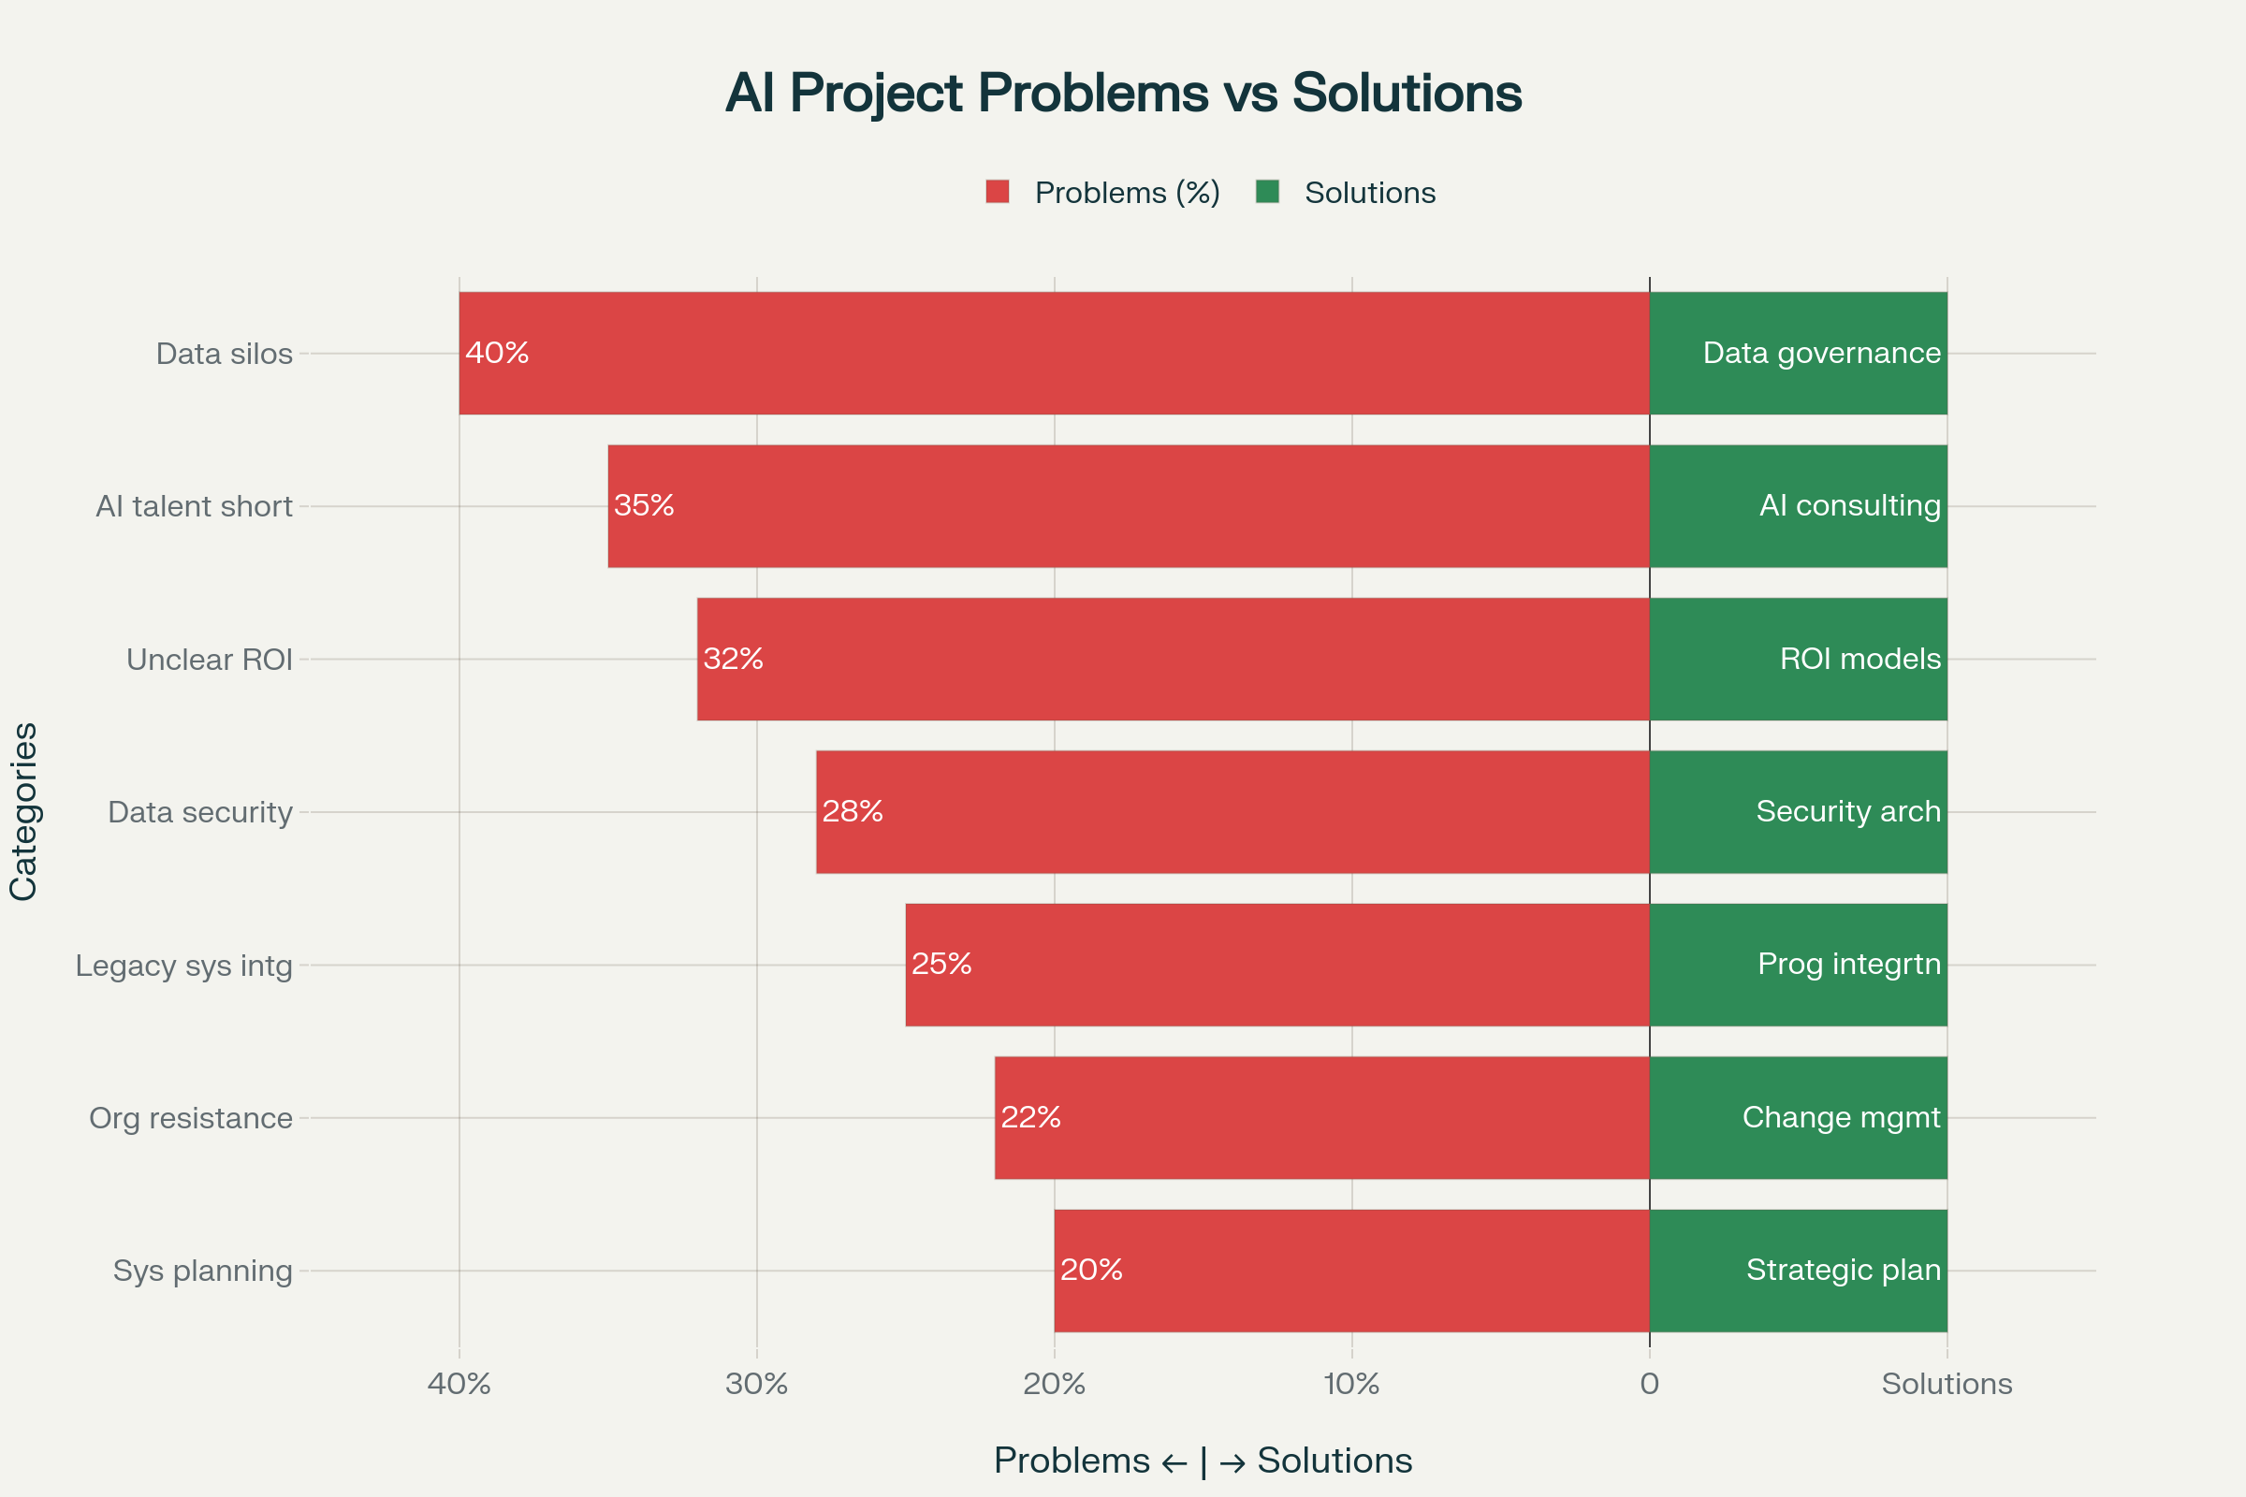
Enterprise AI Transformation Challenges vs ZOKFORCE Solutions

Our Five-Stage Methodology: Lessons Learned in Practice
Through our work with various organizations, we've refined our approach into five distinct stages, each addressing specific pain points we've encountered in real-world implementations.

Stage 1: Strategic Assessment and Risk Evaluation

Business Case Development and Value Quantification
Our experience has taught us that successful AI initiatives begin with rigorous business case development. We work closely with leadership teams to identify high-impact use cases and establish measurable success metrics. Through our projects, we've observed that back-office automation scenarios typically deliver 3-5 times higher ROI compared to customer-facing marketing tools.^{[1]}
During this stage, we conduct comprehensive stakeholder interviews, analyze existing workflows, and develop detailed value propositions that align AI capabilities with specific business outcomes. We've learned that without clear value quantification upfront, projects often struggle to maintain organizational support during inevitable implementation challenges.

AI Maturity Assessment
Drawing from frameworks we've developed through practical experience, our maturity assessment evaluates organizations across multiple dimensions: data infrastructure readiness, existing technical capabilities, workforce AI literacy, and organizational change readiness. This assessment helps set realistic expectations and creates a foundation for phased implementation strategies.^{[9]}
We've found that organizations often overestimate their AI readiness, particularly in areas of data quality and governance. Our assessment provides an objective baseline that helps align expectations and inform resource allocation decisions.

Security and Compliance Framework Development
Given the regulatory complexity we've encountered, particularly around data protection laws, we begin every engagement with a thorough security and compliance assessment. Our team works to ensure alignment with regulations including GDPR, CCPA, and sector-specific requirements, establishing the governance framework that will guide technical implementation decisions.^{[7]}
This upfront investment in compliance architecture has proven invaluable in avoiding costly redesigns and regulatory issues later in the implementation process.

Stage 2: Security-First Architecture Design

Zero-Trust Network Implementation
Based on our experience with security breaches in client environments, we've adopted a zero-trust approach as our standard practice. This involves implementing network micro-segmentation to isolate LLM services from core business systems, ensuring that every interaction requires explicit verification.^{[10]}
Our architecture designs incorporate multiple validation layers and implement least-privilege access principles. We've found that this approach, while requiring more initial setup, significantly reduces long-term security risks and provides better audit trails for compliance purposes.

Data Classification and Tiered Protection
Through our implementations, we've developed a systematic approach to data classification that enables differential protection strategies. We work with client teams to establish clear data sensitivity levels and implement corresponding access controls, encryption standards, and handling procedures.^{[7]}
The key insight we've gained is that effective data protection requires granular classification—not all enterprise data needs the same level of protection, and over-securing can impede AI effectiveness while under-securing creates unacceptable risks.

Privacy-Enhancing Technology Integration
Our experience has shown that advanced privacy technologies—differential privacy, homomorphic encryption, and federated learning—are no longer optional for enterprise AI implementations. We've successfully deployed federated learning solutions that enable "data-never-leaves-the-premises" collaborative model training, addressing one of the most significant concerns we encounter.^{[6]}
These technologies allow organizations to gain AI insights while maintaining strict data sovereignty, addressing both regulatory requirements and competitive concerns about data sharing.

Stage 3: Data Governance and Preprocessing

Data Quality Enhancement
Through multiple implementations, we've learned that data quality issues are often the primary cause of AI project failures. Our approach involves deploying automated data discovery, cleansing, and annotation tools that transform fragmented enterprise data into high-quality AI training datasets.
We implement comprehensive data lineage tracking systems that enable rapid identification and resolution of quality issues. This traceability has proven invaluable during model debugging and compliance audits.^{[11]}
One key learning: organizations often underestimate the effort required for data preprocessing, typically allocating 60-80% of project resources to this stage.

Sensitive Information De-identification
Our experience with various industry verticals has led us to develop sophisticated automated de-identification processes. Using advanced NLP techniques and rule engines, we automatically identify and process sensitive information in documents, conversation logs, and structured data while preserving maximum business value.^{[7]}
The challenge lies in balancing privacy protection with utility preservation—over-aggressive de-identification can render data useless for AI training, while under-processing creates compliance risks.

Secure Prompt Engineering
We've learned through experience that prompt injection attacks represent a significant and evolving threat. Our approach involves developing structured prompt templates that clearly separate system instructions from user inputs, combined with multi-layer input validation and output filtering mechanisms.^{[12][13]}
Our prompt security framework has evolved through real-world testing and includes defenses against both direct and indirect injection attacks, including those that attempt to manipulate AI behavior through external documents or web content.

Stage 4: Secure Deployment and Integration

Sandboxed Testing Environments
Based on our experience with production incidents, we've standardized on using advanced isolation technologies including containers and microVMs for AI application deployment. Our sandbox systems can create secure instances in under 90 milliseconds, enabling high-performance secure computing.^{[14]}
The isolation approach protects both the AI system from external threats and the broader enterprise infrastructure from potential AI-related security issues.

Progressive Production Deployment
We've learned to avoid "big bang" deployment strategies through hard-won experience. Our approach employs blue-green deployment patterns and gradual rollout strategies that minimize business disruption risks while enabling rapid rollback capabilities if issues arise.^{[15]}
Staged deployment allows for real-world validation of AI system behavior while limiting exposure to potential issues. We typically deploy to pilot user groups first, then expand based on performance and user feedback.

Secure System Integration
Through our integration projects, we've developed standardized approaches for connecting AI services with existing enterprise systems. Our unified AI security gateway provides rate limiting, anomaly detection, and real-time alerting capabilities that ensure service stability and security.^{[10]}
Integration challenges often emerge from legacy system limitations and data format inconsistencies. Our experience has taught us to plan for these challenges early and build flexible adapter layers that can evolve with changing requirements.

Stage 5: Continuous Monitoring and Optimization

AI Behavior Anomaly Detection
Our production experience has taught us that AI systems require specialized monitoring approaches. We implement machine learning-based monitoring systems that can detect prompt injection attempts, data leakage risks, and model performance degradation patterns.^{[10]}
Traditional IT monitoring tools often miss AI-specific issues like model drift, bias amplification, or subtle prompt manipulation attempts. Our monitoring approach addresses these unique requirements.

Threat Response and Incident Management
Through our operational experience, we've developed comprehensive security incident handling procedures that include automatic isolation, forensic analysis, and recovery processes. Our security operations approach provides continuous monitoring and rapid response capabilities.^{[16]}
AI security incidents often require specialized investigation techniques, as traditional forensic approaches may not capture the nuances of AI system manipulation or abuse.

Compliance Monitoring and Continuous Improvement
Our experience with regulatory audits has led us to implement automated compliance checking and risk assessment capabilities. Our audit systems generate detailed compliance reports that provide strong regulatory support while identifying areas for continuous improvement.^{[7]}
The regulatory landscape for AI continues to evolve rapidly, requiring adaptive compliance frameworks that can accommodate new requirements without requiring complete system redesigns.

Our Journey and Learnings

Building Deep Industry Understanding
As a growing consulting firm, we've learned that successful AI implementation requires more than technical expertise—it demands deep understanding of industry-specific challenges, regulatory requirements, and business processes. Our team has developed this understanding through hands-on experience across various sectors, learning from both successes and setbacks.
Each industry brings unique data characteristics, regulatory constraints, and business model considerations that significantly impact AI implementation strategies.

Developing Full-Stack Security Capabilities
Through our project experiences, we've built comprehensive capabilities spanning from infrastructure security to application-level protections. Our particular focus on AI security has emerged from witnessing the unique risks that traditional security approaches often miss in AI implementations.
AI security requires specialized knowledge of attack vectors like prompt injection, model inversion, and training data poisoning—threats that don't exist in traditional software systems.

Refining Project Management and Risk Mitigation
Our five-stage methodology represents the distillation of lessons learned from numerous implementations. We've refined our project management practices and risk control mechanisms through real-world experience, always seeking to reduce implementation risks while ensuring successful outcomes.
The key insight: AI projects fail more often due to organizational and process issues than technical limitations. Successful implementation requires careful attention to change management, stakeholder alignment, and realistic expectation setting.

Looking Forward: The Path to AI-Driven Enterprise Success
As we continue to learn and grow in the AI consulting space, we remain committed to helping organizations navigate their AI transformation journeys. The question for most enterprises today isn't whether to adopt AI, but how to do so safely, effectively, and in alignment with their strategic objectives.
Our five-stage methodology represents our current best understanding of effective LLM implementation, but we recognize that this field continues to evolve rapidly. We remain committed to continuous learning, adaptation, and sharing our experiences with the broader business community.
Success in enterprise AI transformation requires more than just cutting-edge technology—it demands systematic methodology, experienced guidance, and comprehensive risk management. Through our continued work with organizations of all sizes, we're committed to refining our approach and contributing to the broader understanding of how to successfully implement AI in complex enterprise environments.
At ZOKFORCE, we view ourselves as partners in our clients' AI journeys, learning alongside them as we collectively navigate this transformative technology landscape. We believe that by sharing our experiences and continuously improving our methodologies, we can help more organizations successfully harness the power of AI while maintaining the security, compliance, and operational standards their stakeholders demand.
The future belongs to organizations that can successfully integrate AI into their operations while managing the associated risks and complexities. Our five-stage methodology provides a roadmap for this integration, but the journey requires commitment, patience, and the willingness to learn and adapt as the technology landscape continues to evolve.
⁂

- https://fortune.com/2025/08/18/mit-report-95-percent-generative-ai-pilots-at-companies-failing-cfo/
- https://www.woshipm.com/ai/6231601.html
- https://www.21jingji.com/article/20250916/herald/e9d53ee2894e2813b5412df02fd09767.html
- https://blog.csdn.net/yuntongliangda/article/details/152639416
- https://www.businesswire.com/news/home/20250520394499/zh-CN
- https://coralogix.com/ai-blog/the-security-risks-of-using-llms-in-enterprise-applications/
- https://www.superblocks.com/blog/enterprise-llm-security
- https://www.stack-ai.com/blog/the-biggest-ai-adoption-challenges
- https://www.weforum.org/stories/2025/10/closing-the-intelligence-gap-how-leaders-can-scale-ai-with-strategy-data-and-workforce-readiness/
- https://www.mend.io/blog/llm-security-risks-mitigations-whats-next/
- https://www.congruity360.com/blog/building-your-ai-data-governance-framework/
- https://docs.aws.amazon.com/prescriptive-guidance/latest/llm-prompt-engineering-best-practices/introduction.html
- https://quokkalabs.com/blog/prevent-prompt-injection-llm/
- https://edera.dev/stories/securing-agentic-ai-systems-with-hardened-runtime-isolation
- https://www.ey.com/en_us/insights/technology/four-steps-for-implementing-a-large-language-model-llm
- https://learn.microsoft.com/zh-cn/azure/cloud-adoption-framework/scenarios/ai/secure

